Students' Co-regulation and Leadership During a Complex Problem-Solving Assessment: An Eye-Tracking Study

Abstract

Understanding how students co-regulate their learning during complex problem-solving has typically relied on indirect measures. In this study, conducted using in-situ eye-tracking, we provide insight into co-regulation as a process unfolding over time. Three collaborating engineering undergraduates wore eye-tracking sets during an in-class, complex assessment. By calibrating the three data streams, we defined moments of shared attention. Analysis of data streams by question, paired with activity-coded content logs, reveals patterns of co-regulation related to monitoring and evaluating. Notably, the students' accounts of leadership differed from empirically-derived leading. While confident, the students' gazes aligned, but when faced with uncertainty, they diverged, converging again as they evaluated the accuracy of their answers. These findings provide an empirical account of co-regulation as a process.

Keywords: Leadership, Joint Visual Attention, Co-regulation, Cross-recurrence Quantification Analysis, Diagonal Cross-recurrence Profile, Multidimensional Recurrence Quantification Analysis

# **1.** **Introduction**

Understanding how to support students to collaboratively solve complex problems has been a major focus of research in the learning sciences, with most studies investigating the processes through analysis of video recordings and products and outcomes through both qualitative and quantitative methods. More recently, laboratory-based research studies have used eye-tracking methods to investigate how individuals approach and solve problems (Sharma et al., 2017); the increased availability of lower cost eye-tracking systems and advances in ways to integrate multiple data streams have made possible the study of collaborative problem solving (Jermann, Mullins, Nüssli, & Dillenbourg, 2011); most such studies have occurred in laboratory settings (Ho, Foulsham, & Kingstone, 2015).

We sought to explore the potential of mobile eye-tracking as a means to reveal how three collaborating students approached complex problem solving *in-situ*. Specifically, we were curious about how they co-regulated their learning and what role leadership played in their problem solving processes. Although leadership has been explored extensively in social psychology, small group research, and management (e.g. Avolio, Kahai, & Dodge, 2000;Hannah, Avolio, Luthans, & Harms, 2008; Yulk, 1989), studies of leadership in learning contexts are comparatively rare.

Co-regulation is a relatively new phenomenon that has been discussed in the collaborative learning literature (e.g. Jarvela, Jarvenoja, Malmberg, & Hadwin, 2013; Hadwin, Jarvela, & Miller, 2018). Most measures of co-regulation provide indirect snapshots of students’ co-regulation (e.g. Didonato, 2013; Law, Ge, Eseryel, 2016), providing limited details regarding how co-regulation unfolds over time.

Integrated gaze data of collaborating students may shed light on the role of leadership in co-regulation. The purpose of this study was to explore the potential of mobile eye-tracking as a means to reveal leadership and co-regulation of three collaborating students during in-situ complex problem solving. To guide our work, we posed the following research questions:

* What does gaze data reveal about students’ leadership during a collaborative problem solving process?
* What does gaze data reveal about students’ monitoring and evaluation of their collaborative problem solving process?

# 2. Review of the Literature

To guide our study, we first consider research on how students co-regulate their learning in collaborative problem solving. We argue leadership enhances co-regulation skills, which, in turn, support collaborative problem solving. We then review research suggesting that gaze data provides more direct information about cognitive processes, including leadership within a small group. We review recent approaches to analyzing gaze data.

## 2.1. Co-regulation and leadership behaviors support collaborative problem solving

Self-regulation provides a lens for characterizing the ways individuals dynamically plan, monitor, and evaluate their understanding and learning. Learners who plan, monitor, control, and reflect/evaluate are more successful (Azevedo, Guthrie, & Seibert, 2004). Self-regulation has been investigated using eye-tracking with individual learners under laboratory conditions (Trevors, Feyzi-Behnagh, Azevedo, & Bouchet, 2016).

Co-regulation extends self-regulation, considering how learners regulate themselves within a group environment (Hadwin, Järvelä, & Miller, 2018). Groups that co-regulate effectively have greater learning outcomes (Zheng, Kumar & Kinshuk, 2014). Thus, simply placing students together is not sufficient (Chan, 2012; Volet, Summers, & Thurman, 2009).

Past research theorized a link between self-regulation and leadership. An empirical test of this relationship found that leadership behaviors may cue self-regulation strategies (James, 2009). In collaborative learning, leadership plays a crucial role as members need to agree on and share responsibilities during learning and complex problem solving (Chiu, 2008), yet leadership has not been studied as part of co-regulation. Members must negotiate on how to frame problems, divide work, monitor progress, and agree on solutions. Without leadership, these complex tasks can become challenging. Whether formally appointed or emergent, leadership can positively impact collaborating groups, for instance, resulting in better online discussion (Xie, Yu, and Bradshaw, 2014) and guiding turn-taking and argument development (Gressick & Derry, 2010; Li et al., 2007). Thus, leadership behaviors lead to regulatory behaviors, which, in turn, positively influence student learning outcomes (Xie, Hensley, Law, & Sun, 2019).

## 2.2. Eye movements are related to cognitive processes and leadership

Previous research has established relationships between eye movements and cognitive processes (Konig et al., 2016; Rodrigues & Rosa, 2017). Researchers agree on the close link between eye movements and attention in activities such as reading and typing (Rayner, 1998, 2009). Eye movement behavior is connected to the quality of memorization (Damiano & Walther, 2019), as well as to information processing and characteristics of learning outcomes as found in multimedia learning situations (Desjarlais, 2017). Likewise, in problem-solving processes, successful students tend to focus their gaze on relevant elements, such as selected solutions when multiple-choice options are presented and on the problem statement (Tsai, Hou, Lai, Liu, & Yang, 2012). Such linkages occur because eye movement patterns are mental activities that unveil and affect problem-solving as a type of cognitive process (Spivey & Dale, 2011). Moreover, there is evidence that the cognitive goals of the specific activity determine the eye movement behavior (Hayhoe & Ballard, 2005), like the increase in the number of fixations (gazes that last more than 200 ms at the same point) during the evaluation stage of a decision-making process, compared to a related search activity (Gidlöf, Wallin, Dewhurst, & Holmqvist, 2013).

Extending these insights to collaborative situations requires focus on both what individuals are doing and whether they appear to be attending to the same tasks. Joint attention and shared cognition are positively connected during effective collaborative problem-solving activities (Barron & Roschelle, 2009), where learning happens as a synergy based on common ground and effort (Schneider et al., 2018; Schwartz, 1995). In collaborative gaze studies, this is characterized by joint visual attention (JVA) (Schneider et al., 2018). Different rates of JVA during collaborative tasks are related to learning acquisition (Belenky, Ringenberg, Olsen, Aleven, & Rummel, 2014) and to the level of success of pair collaboration (Villamor & Rodrigo, 2019). Differences in patterns of eye-movement behavior in paired, collaborative problem-solving tasks are also related to differences in prior knowledge, level of success, and the specific stage in the problem-solving process (Sharma, Olsen, Aleven, & Rummel, 2018).

Gaze data also provide insight into leadership behaviors. In social situations, people tend to look more often at those perceived as leaders or as having high status (Foulsham, Cheng, Tracy, Henrich, & Kingstone, 2010). Team members not only look for the leader’s signals, but also tend to follow their gaze (Gerpott, Lehmann-Willenbrock, Silvis, & Van Vugt, 2018; Gontar & Mulligan, 2016). However, when *placed* in a leadership role, a leader who does not demonstrate leadership behaviors may fail to garner gaze following from other members (Capozzi, Becchio, Willemse, & Bayliss, 2016; Dale, Kirkham, & Richardson, 2011).

## 2.3. Eye-tracking data allow for analyzing eye movements using different approaches

Eye-tracking devices are widely used in research involving eye movement because eye-trackers allow for various measures of eye movements and visual attention (Hayhoe & Ballard, 2005) through the recording of the user’s eye(s) and the surroundings. Once the researchers determine the areas of interest (AOI), which are regions (features or objects) involved in the processes under study, eye-tracking detects specific locations at which the eye is looking (gaze points), the duration of the gaze within an AOI, gazes that last more than 200 milliseconds (fixations), and movements of the eye between two fixations (saccades). Gaze points and duration, fixations, and saccades are common measures provided by eye-tracking technology in educational research (Cook & Wei, 2017; Rodrigues & Rosa, 2017), which can be analyzed using a wide range of procedures. We describe these next.

### **2.3.1. Cross-recurrence quantification analysis (CRQA)**

Eye-tracking data consists of time series of noisy and complex information. Cross-recurrence quantification analysis (CRQA) is an adequate approach to combine two time series originating from the eye movements of the members of a pair to study “interpersonal cognitive coordination” (Shockley & Riley, 2015, p. 413), the coordination of their joint attention (Richardson, Dale, & Kirkham, 2007), and the quality of their interaction (Jermann, Mullins, Nüssli, & Dillenbourg, 2011), among others. CRQA plots and measures represent and quantify the similarity of two time series based on the repetition of elements or recurrence (Coco & Dale, 2014; Marwan & Kurths, 2002; Wallot & Leonardi, 2018). For example, Figure 1 represents a recurrence plot and a cross-recurrence plot of sequences of letters that could represent coded AOIs, meaning that each letter corresponds to a different feature or object where a participant is looking at (reproduced from Wallot & Leonardi, 2018). Figure 1A visualizes the recurrence of the same sequence of letters (same sequence on both axes), and Figure 1B visualizes the cross-recurrence of two different letter sequences; the black squares represent recurrence points because both associated letters (horizontal and vertical axes) are the same. Percent recurrence (%REC) is one of the main recurrence measures associated with cross-recurrence plots; %REC describes the number of recurrent points in the recurrence plot, which is 28% on 1A and 22% on 2A (number of black squares out of 100 total squares). Percent determinism (%DET) is another core measure, which computes repetitions on connected diagonals; Figure 1A presents a 71.4% determinism (20 black squares on diagonal lines out of a total of 28 black squares), and Figure 1B presents a 63.6% determinism (14 squares aligned on diagonals out of 22 black squares). Additional cross-recurrence measures are Average Diagonal Line Length (ADL; 6.7 for 1A and 3.5 for 1B) and Maximum Diagonal Line Length (MDL; 10 for 1A and 5 for 1B). Measures involving diagonals describe patterns of shared participant behaviors over time.

**Figure 1**

*Illustration of recurrence of letters in the sequence "ABCDABCD"* ***(A)****, and cross-recurrence of letters "ABCDABCD" with "DDEFGABCDD"* ***(B)***

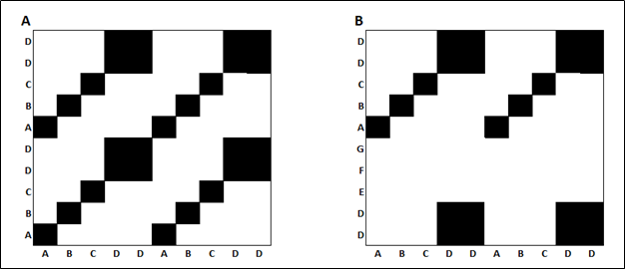

*Note*. The black squares in the matrices indicate the recurrence of a letter, and white spaces indicate the absence of recurrence. From “Analyzing multivariate dynamics using cross-recurrence quantification analysis (CRQA), diagonal-cross-recurrence profiles (DCRP), and multidimensional recurrence quantification analysis (MdRQA)–a tutorial in R,” by S. Wallot & G. Leonardi, 2018, Frontiers in psychology, 9, p. 3. Copyright by the authors. Reprinted with permission.

### 2.3.2. Diagonal cross-recurrence profiles (DCRP)

The main diagonal or Line of Synchrony (LoS) of a cross-recurrence plot corresponds to the values of the time series occurring at the same time. The study of that diagonal and its surrounding area is called Diagonal Cross-Recurrence Profile (DCRP), which is useful to determine leader-follower behaviors (Dale et al., 2011; Richardson & Dale, 2005; Wallot & Leonardi, 2018). A higher number of recurrence points on one side of the LoS within a narrow band along with it suggests the existence of leader-follower behavior because the gaze of the follower will visit the different AOIs with a certain lag after the visit of the leader (Fusaroli, Konvalinka, & Wallot, 2014). Figure 2 shows a diagonal-wise cross-recurrence plot where the maximum value of recurrence (maxrec measure) occurs on the left of the LoS, line where the time lag is equal to zero, at a certain time lag (maxlag measure). If the maximum occurs on the left of the LoS, the participant represented on the horizontal axis of the corresponding recurrence plot would lead the interaction; if the maximum appears on the right, the leader would be the participant on the vertical axis of the recurrence plot.

**Figure 2**

*Diagonal cross-recurrence profile with a maximum on the left of the line of synchrony (lag = 0)*

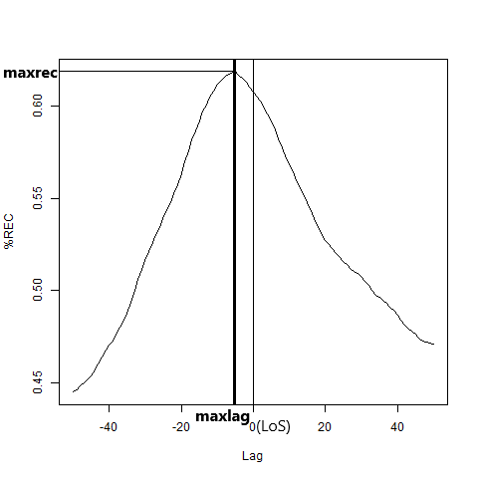

### 2.3.3. Multidimensional recurrence quantification analysis (MdRQA)

The limitation of CRQA to dyads is overcome by the application of Multidimensional Recurrence Quantification Analysis (MdRQA), a tool that allows for the recurrence analysis of more than two time series (Wallot & Leonardi, 2018; Wallot, Roepstorff, & Mønster, 2016). MdRQA also yields recurrence plots and similar quantification measures, although with the drawback of a less intuitive interpretation of the actual underlying phenomena and results obtained. While each axis of a cross-recurrence plot represents the time series corresponding to a single participant, both axes in a MdRQA plot are identical and represent a combination of the time series corresponding to *all* the participants. For example, we can represent the AOIs at which three participants are looking at a particular moment as the triad *first-participant-AOI second-participant-AOI third-participant-AOI*. If we use letters to code the AOIs, the triad ABB would mean that, at a particular time, the first participant was looking at the area coded as A, the second participant was looking at area B, and the third participant was also looking at area B. The values on the axes correspond to consecutively observed triads; therefore, the recurrence points in the MdRQA plot represent the different times at which the same triad occurred. Figure 3 visualizes a simple MdRQA plot representing the consecutive triads ACB, ABB, AAA, AAC, ABB, ABB, DAB, and CCC. As can be seen, both axes are identical, the plot is symmetric along the main diagonal, and the only recurrence points correspond to the triad ABB and the main diagonal. Recurrence points in a MdRQA plot do not represent joint attention but a pattern of the team’s interaction as a whole.

**Figure 3**

*Illustration of a MdRQA plot of the consecutive triads ACB, ABB, AAA, AAC, ABB, ABB, DAB, and CCC*

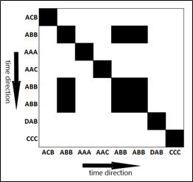

# 3. Methods

## 3.1. Research design

We extended methods reported elsewhere for mobile eye-tracking of co-located dyads (Schneider et al., 2018) to triads. Below, we describe our in situ data collection approach and analysis strategies.

## 3.2. Participants & setting

We conducted the study in a required undergraduate engineering course on control theory at a research university in the southwestern US. The course enrolled 63 students, 16 from electrical and computer engineering, and 47 from mechanical engineering. Students participated in six in-class, scenario-based collaborative exams. Each exam included five questions, in roughly increasing order of complexity. Students worked in self-selected teams of three and chose which role (recorder, leader, monitor) to occupy.

We focused on the fifth exam that consisted of five questions. On this exam, the scenario involved an automatic focusing system in a charge-coupled device camera onboard the Mars Insight space mission. Solving the problems associated with the scenario required analysis via Nyquist and Bode methods. Students were provided with a transfer function model that described the dynamics of the lens positioning system. Students could apply tools for analysis of Nyquist diagrams and examine the relationship between Nyquist, Bode, and root locus diagrams. Specifically, students were asked to identify gain margin and phase margin in Nyquist diagrams, and challenged to relate these metrics to measures of stability via root locus and Bode diagrams.

## 3.3. Data collection

For the data collection, we used three Pupil Labs eye-trackers ([www.pupil-labs.com](http://www.pupil-labs.com/)) that consisted of a headset with a front (world) camera, an eye camera, and a USBC cable (Kassner, Patera, & Bulling, 2014). The headset is worn like a pair of glasses, and it is connected to a mobile device. After the required adjustments and calibration, the eye-tracker records a video of the eye of the user and a video of the different AOIs (world camera). We chose a team of three students who were willing to participate and did not wear glasses, which could hamper the correct adjustment and functioning of the eye-trackers. Each student on the team wore an eye-tracker for the duration of the exam.

## 3.4 Data analysis

We processed each pair of coupled eye and world videos with an ad hoc application to compute gaze points, fixations, and saccades. The results of the video processing were augmented reality videos, where gaze points are represented as dots, fixations as rings, and saccades as lines within the front camera images. For the purpose of this study, we were interested in gaze points on different areas of interest (AOI) such as a computer, exam hardcopy, participants, calculators, and notebooks. The abundance of AOIs, the nature of some of them, such as the participants themselves, and the actual testing context of the natural setting under study prevented us from using fiducial markers to automate the collection and analysis of eye movements. Therefore we manually registered successive gaze positions (AOI) and their durations (tenths of second) from the processed video, using fixations and saccades as auxiliary measures to determine gaze points.

We synchronized the content logs and converted them into time series formed by the synchronized time in tenths of second and the AOIs coded as numbers for each participant. The rows of the time series correspond to consecutive tenths of second with no gaps in between from the beginning to the end of each video content log. The coding strategy was crucial for this study. Table 1 shows some of the codes we used for each of the three participants. We coded with the same number for each participant the AOIs directly involved in the collaboration process, such as a computer, the exam hardcopy, participants, calculators, notebooks, professor, and another team that was sharing the same table, to capture joint and shared attention. For example, we coded the computer as 1, the exam hardcopy as 2, and participants as 3. Objects not involved in the problem-solving process such as cellphones not used as calculators, walls, students at different tables in the classroom, and water bottles, among others, received a different code for each participant to avoid the false detection of joint attention. For example, a situation where the participants were checking their social media was not detected as joint attention because each cellphone received a different code.

**Table 1**

*Examples of codes assigned to the AOIs for each participant*

|  |  |  |  |
| --- | --- | --- | --- |
| AOI | Codes | | |
|  | Nathaniel | Steven | Jackson |
| Computer | 1 | 1 | 1 |
| Exam hardcopy | 2 | 2 | 2 |
| Participant | 3 | 3 | 3 |
| Nathaniel’s calculator | 6 | 6 | 6 |
| Nathaniel’s notebook | 7 | 7 | 7 |
| Steven’s calculator | 8 | 8 | 8 |
| Steven’s notebook | 9 | 9 | 9 |
| Professor | 11 | 11 | 11 |
| Another team at table | 13 | 13 | 13 |
| Object not involved | 10 | 18 | 19 |

Note: The names of the participants are pseudonyms.

We split the data into five parts corresponding to each exam question to later conduct CRQA, DCRP, and MdRQA of the time series, which would allow for extracting disaggregated behavior patterns based on similarities found in gaze behavior, such as joint (participants looking at the same AOI), shared (participants looking at each other), and recurrent (participants revisiting AOIs) gazes.

We applied CRQA and DCRP to dyads of students (Nathaniel-Steven, Nathaniel-Jackson, and Jackson-Steven) using approaches available in the R package crqa (Coco & Dale, 2014), within an RStudio environment. We obtained 15 cross-recurrence plots and 15 diagonal cross-recurrence profiles, one per student dyad and exam question. A CRQA plot combines two time series to create a pattern of repetitions, where each square represents an AOI co-visited by both participants at the same or different times. The horizontal axis represents the time, in tenths of second, for the first student and the vertical axis tenths of second for the second student. The main diagonal or line of synchrony (LoS; from top left to bottom right in this study) represents AOIs visited by both participants at the same time. A diagonal cross-recurrence profile represents the level of recurrence at certain lags around the LoS for two participants. The presence of a maximum value of recurrence before or after the LoS could suggest the existence of a leader-follower relationship because one participant would tend to visit AOIs recently visited by the other participant. We also computed a set of quantification measures associated with the different plots, such as %REC, %DET, ADL, MDL, maxrec, and maxlag (Table 2).

We applied MdRQA to the triad of students for each question, which yielded five multidimensional recurrence plots and their corresponding quantification measures (Table 2). We used the R version of the MdRQA function developed by Sebastian Wallot and Dan Mønster (Wallot & Leonardi, 2018; Wallot et al., 2016) to compute the analysis.

**Table 2**

*Cross-recurrence measures utilized in this study*

|  |  |  |
| --- | --- | --- |
| Type of Analysis | Measure | Description |
| CRQA or MdRQA | %REC: Percent Recurrence | Computes number (ratio) of recurrence points in the plot |
|  | %DET: Percent Determinism | Computes number (ratio) of repetitions that are connected on diagonals |
|  | ADL: Average Diagonal Length |  |
|  | MDL: Maximum Diagonal Length |  |
| DCRP | maxrec: Maximum Recurrence | The highest recurrence value computed along a diagonal line within a band determined around the LoS |
|  | maxlag: Lag at maxrec | The value of the time lag between both time series on the diagonal line where maximum recurrence occurs |

Note: CRQA stands for cross-recurrence quantification analysis, MdRQA stands for multidimensional recurrence quantification analysis and DCRP diagonal cross-recurrence profile.

# 4. Results

We present results organized by research question.

## 4.1 Research question 1: Leadership

As the fifth exam of the course, the students should have been familiar with the expectation of taking on roles of leader, recorder, and monitor. In this case, Nathaniel (names are pseudonyms) served as recorder, whose role was therefore to keep an organized written record of the group's ideas and copy the answers onto grading sheet; Steven as leader, whose role was therefore to keep the group on task to complete allotted work; and Jackson as monitor, whose role was therefore to monitor members' learning and inform the leader when the pace is too fast or slow, impairing the group learning.

The following results are based on the examination of the DCRPs for each dyad and question. On the first exam question, Nathaniel led Steven and Jackson, with more than half a second lag (Figure 4 A and B). While Jackson seemed to lead Steven (Figure 4 C), the lag is small, meaning both could have followed Nathaniel at about the same time. On the second question, the only leader-follower relationship seems to exist between Nathaniel (leader) and Jackson (follower, seven tenths of second lag; Figure 4 E). Nathaniel and Steven present a strong and balanced simultaneous pattern, and there is no apparent leader-follower relationship between Steven and Jackson, presenting a weaker simultaneous pattern (two tips with a central depression; Figure 4 F). On the third exam question, Nathaniel again led Steven and Jackson (Figure 4 G; about half a second lag). Steven seems to lead Jackson but the lag is very small; the meaning could be that both follow Nathaniel at about the same time. On the fourth question, the only leader-follower relationship can be found between Nathaniel (leader) and Jackson (follower, 7 tenths of second lag; Figure 5 K). Finally, on the fifth question, the only leader-follower relationship can be found again between Nathaniel (leader) and Jackson (follower, half a second lag; Figure 5 N).

**Figure 4**

*Diagonal cross-recurrence profiles for questions 1, 2, and 3*

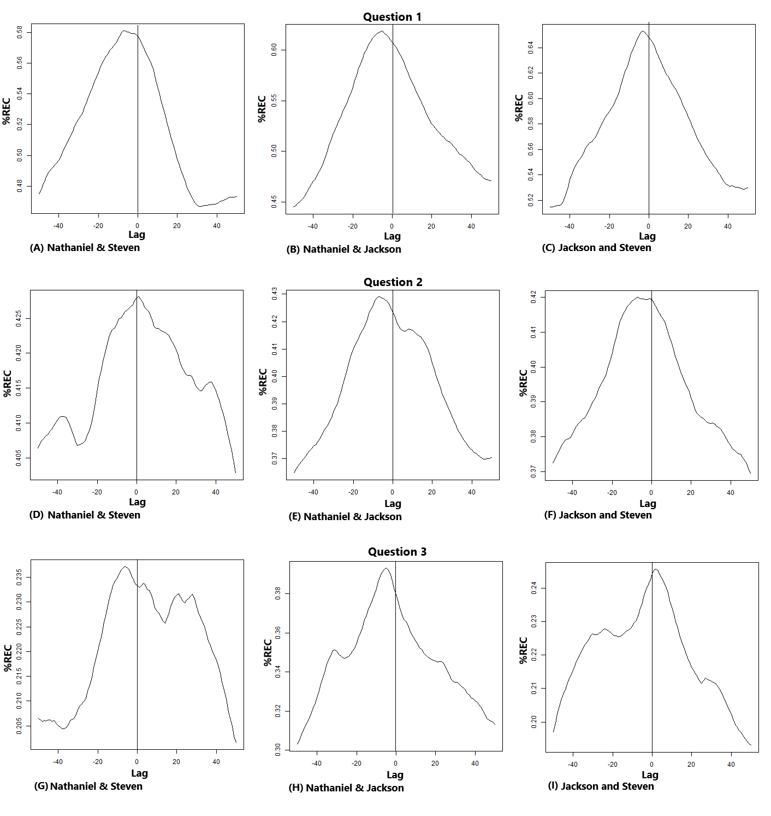

**Figure 5**

*Diagonal cross-recurrence profiles for questions 4 and 5*

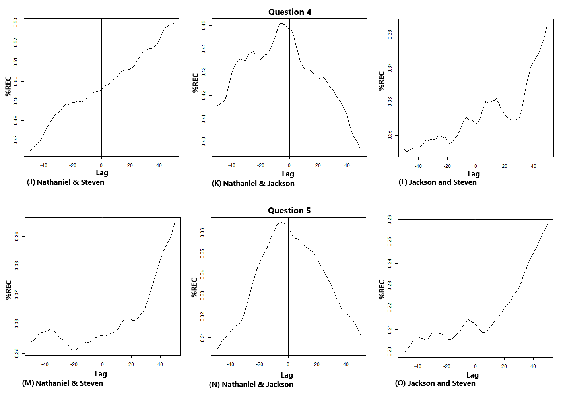

## 4.2 Research question 2: Monitoring and evaluating

We are focusing our description of results on the plots and %REC, because the variability of %DET is low in our results, and the diagonal measures ADL and MDL can not be used to compare across questions because their values depend on the length of each solving process. Table 3 summarizes the quantification measures computed in the CRQA.

On the first exam question, the problem-solving process was quick (five minutes), sustained, and involved a mostly accurate discussion among the three students, resulting in a correct answer. The CRQA yields cross-recurrence plots (Figure 6 A, B, and C) that show a high recurrence rate (between 36.24% and 44.93%) reflected in many black squares. Cross-recurrence plots show higher recurrence rates intervals as darker regions (higher black square density). In this case, the overall level of recurrence decreased somewhat over time, but increased in the final minute of work, meaning the students' gazes became less coordinated as they worked but then more coordinated towards the end when they reached and wrote the final answers. Most of the white stripes have black squares on the main diagonal or elsewhere, meaning they were working together but focused on different personal objects. For instance, as one student was doing math on his notebook, another was using his calculator, and the third was typing. As the students worked toward a solution, they began to look at each other’s personal objects. The MdQRA plot (Figure 8 A) shows two different types of coupling of the team as a whole. A first type occurred during the first half of the solving process and by the end, as in the CRQA plots’ higher recurrence areas, characterized by a pattern of alternate dark recurrence rectangles and clean stripes. A second type, which resembles a checkerboard and corresponds to the lower recurrence areas in the CRQA plots. Both patterns are capturing two differentiated teamwork structures; first where the student gazes frequently visit the most common shared AOIs (e, g. computer) and second where they visit a less frequent combination of AOIs (e. g. personal objects).

**Figure 6**

*Cross-recurrence plots for questions 1, 2, and 3*

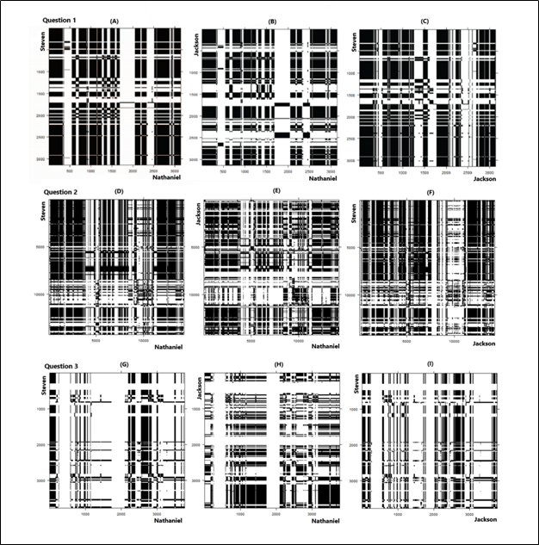

**Figure 7**

*Cross-recurrence plots for questions 4 and 5*

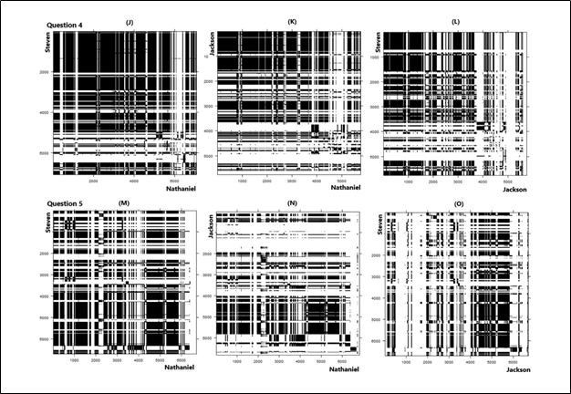

**Table 3**

*CRQA quantification measure results by questions and dyad*

|  |  |  |  |  |
| --- | --- | --- | --- | --- |
| Measure | Nathaniel–Steven | Nathaniel-Jackson | Jackson-Steven |  |
| First Question | | | | |
| %REC | 45.93 | 36.24 | 44.18 |  |
| %DET | 99.97 | 99.94 | 99.95 |  |
| ADL | 43.00 | 33.41 | 36.15 |  |
| MDL | 323 | 307 | 307 |  |
| Second Question | | | | |
| %REC | 28.14 | 21.46 | 24.13 |  |
| %DET | 99.93 | 99.87 | 99.89 |  |
| ADL | 31.26 | 22.64 | 24.78 |  |
| MDL | 743 | 532 | 528 |  |
| Third Question | | | | |
| %REC | 16.09 | 20.45 | 16.09 |  |
| %DET | 99.79 | 99.80 | 99.85 |  |
| ADL | 22.26 | 17.64 | 14.33 |  |
| MDL | 195 | 287 | 102 |  |
| Fourth Question | | | | |
| %REC | 40.45 | 26.31 | 23.94 |  |
| %DET | 99.97 | 99.87 | 99.87 |  |
| ADL | 42.83 | 21.10 | 20.89 |  |
| MDL | 428 | 293 | 305 |  |
| Fifth Question | | | | |
| %REC | 32.77 | 17.37 | 18.20 |  |
| %DET | 99.96 | 99.91 | 99.90 |  |
| ADL | 39.57 | 24.15 | 23.71 |  |
| MDL | 459 | 292 | 298 |  |

On the second exam question, the students took the longest time—approximately 22 minutes but were not entirely correct (3.75 out of 5 points). The cross-recurrence plots (Figure 6 D, E, and F) show a lower recurrence rate (between 21.46% and 28.14%). Two main reasons can explain the lower recurrence rate. First, the longer duration allowed for more distraction periods, shown as clean white stripes on the recurrence plots. Second, as can be seen in the central part of the plots, the solving process was characterized by cooperative work, where the participants focused on their personal objects while figuring out answers, sharing information, giving feedback, finding inconsistencies, and troubleshooting (reflected in white stripes with some black interruptions). The overall level of recurrence is higher at the beginning of the solving process (the first approach to the question solving) and by the end (students getting conclusions and writing/correcting the answers on the exam hardcopy). The MdRQA plot (Figure 8 B) also captures two different whole team coupling patterns (beginning/end and cooperative work), similar to the first question results, compatible with the patterns found in the CRQA plots.

**Figure 8**

*Multi-dimensional recurrence plots*

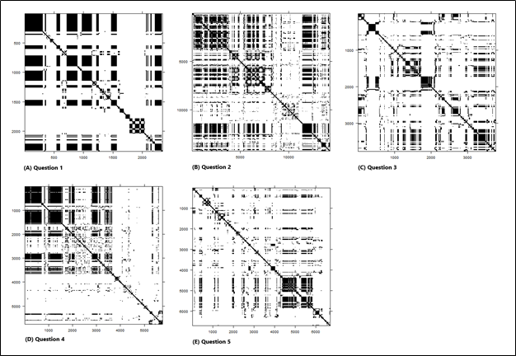

On the third exam question, the students took seven minutes to come to a correct answer, which required a longer written answer. The cross-recurrence plots (Figure 6 G, H, and I) present low recurrence rates (between 16.09% and 20.45%), characterized by cooperative work (white stripes with black interruptions) and distraction (text messages/social media, represented by clean white stripes). The higher recurrence rate occurs between Nathaniel (writing their answer) and Jackson, because Jackson was more focused on Nathaniel’s writing than Steven, who used the computer to provide and check answers. That cooperative work yielded cross-recurrence plots that contain white stripes with black square interruptions. The level of recurrence is higher by the end of the solving process, when the writing was happening. The MdRQA plot (Figure 8 C) also captures three different patterns. The first pattern occurs around 500 and 1900 tenths of second, with two white stripes that contain a central black area and correspond to unfocused periods. The second pattern spreads over the plot, showing thinner stripes alternating the different teamwork situations described above (unfocused, cooperative work, and higher attention to shared AOIs). Finally, a section with higher recurrence culminates the solving process.

The solving process for the fourth question was characterized by a strong recurrence rate between Nathaniel and Steven (%REC = 40.45) who were focused on the same objects often; the last part of their recurrence plot (Figure 7 J, K, and L) shows a cooperative work pattern. Jackson presents a similar focused behavior for more than half the solving process time, but he starts having not engaged periods very often after about the 3600 tenths of second; therefore his recurrence rates are smaller (%REC = 26.31 and 23.94), suggesting that Jackson is less involved in the second half of the process than his teammates. The time interval when successive periods of cooperative work and disengagement are prevalent corresponds to a stage where the students were struggling to find the correct answer, after getting help from the instructor. During that period, they tried to get help from other classmates. They eventually reached the right answer, although Jackson was distracted while Nathaniel was writing and Steven assisting at the end of the process. The overall level of recurrence decreases over time until a final increase within the last minutes for the reasons explained above. The MdRQA plot (Figure 8 D) makes even more evident the effect of one unfocused participant on the team work; the second part of the plot, where the most distractions of Jackson happen, shows a much smaller number of recurrence points than the first part.

The solving process for the fifth question was characterized again by a stronger recurrence rate between Nathaniel and Steven (%REC = 32.77) who were focused on the same objects often. Jackson expands the disengagement pattern started in the previous question, having even more unfocused periods reflected in much lower recurrence rates (%REC = 17.37 and 18.20), suggesting that Jackson is even less involved in the solving process of this question than before. He rejoined the team solving efforts after the 4000 tenths of a second mark. The overall level of recurrence increases after the mentioned 4000 tenths of a second mark, when the students were finishing and wrapping up the exam. The answer to this question was correct. The MdRQA plot corresponding to this question (Figure 8 E) is clearly compatible with the previous description of the solving process because it shows a higher recurrence area by the end of the solving process.

# 5. Conclusions

Research studies have explored the concept of emergent leadership to understand how leaders emerge in collaborative environments, usually using surveys/self-report data (Xie et al., 2014) or observing collaborative episodes and coding behaviors (Carte, Chidambaram, & Becker, 2006; Li et al., 2007). We used eye-tracking to capture collaboration data, observing two interesting phenomena. First, gaze data suggested the self-selected leader, Steven, was not actually leading. Instead, he was distracted on multiple occasions. Nathaniel, in the role of recorder, led throughout the collaborative problem solving. Perhaps Steven's conceptualization of leading was delegating—an effective strategy under some conditions, but not one likely to result in regulation behaviors or learning. Yet, Nathaniel's emergent leadership behaviors provided support for co-regulation. This suggests self-assigned leaders may not represent leadership behaviors accurately. Second, there are limitations in using self-report data, and coding can be time-consuming (Greene, 2015; Winne, 2010) Although gaze data is a proxy, it can provide an indicator of where, in video data, to look for emergent leadership behaviors, making coding more manageable.

Overall, the recurrence rate was higher at the beginning and the end of each question; lower recurrence rates in between were due to distractions and, more frequently, cooperative work, with participants working together but focused on personal objects, suggestive of co-regulation. Our results confirmed that co-regulation is dynamic in nature (e.g. Malmberg, Järvelä & Järvenoja, 2017; Järvelä, Järvenoja, & Veermans, 2008). To understand the dynamic nature of co-regulation, researchers have been analyzing behavioral logs (e.g. Zheng, Xing, & Zhu, 2109), video clips (e.g. Järvelä et al., 2008), and team discussion board (e.g. Kim & Lim, 2018). Our research suggested eye-tracking data can be useful in understanding the dynamic of co-regulation.

Empirical studies and theoretical papers support the use of different recurrence analysis approaches to study time series (Coco & Dale, 2014; Wallot & Leonardi, 2018) and, specifically, the gaze data collected with eye-trackers (Dale, Kirkham, & Richardson, 2011; Jermann, Mullins, Nüssli, & Dillenbourg, 2011; Richardson, Dale, & Kirkham, 2007; Shockley & Riley, 2015). We applied diagonal cross-recurrence profiles (DCRP), cross-recurrence quantification analysis (CRQA), and multi-dimensional recurrence quantification analysis (MdRQA) to obtain plots and measures that characterized the nature of the collaborative problem-solving interactions and behavior observed among the three participants in this study.

The DCRP plots were consistent across exam questions identifying possible leader-follower relationships; the CRQA plots and measures were consistent across exam questions and dyads, providing graphical patterns associated with different types of participant interactions. The results of the MdRQA were also consistent with the obtained through CRQA, which bring about caveats and potentialities. As explained before, the interpretations of CRQA and MdRQA outcomes are different by definition; while the former computes recurrence of joint attention situations, the latter calculates recurrence of, in our case, participant gaze triads that do not have to correspond to joint attention. That conceptual difference could lead to misinterpretations of results when applied to similar data. Although MdRQA is also suitable for the study of individuals and dyads (Wallot, Roepstorff, & Mønster, 2016), we decided to apply CRQA to dyads to capture precise joint attention information, which would be missed by a dyadic MdRQA. In addition to that, the ability of MdRQA to process whole group dynamics encouraged us to include it in this study; that capability also allows for the study of bigger teams without the inconvenience of generating multiple dyadic plots that could be difficult to interpret together. The results of this study suggest that both CRQA and MdRQA are compatible; researchers can leverage the advantages of the combination of both approaches if they take the necessary precautions. That combination could be used to identify and classify team dynamic as a whole, and the nature of the individual contributions of each member of the team to that dynamic.

## 5.1 Limitations and future research

Our approach highlighted the feasibility of collecting eye-tracking data from three students during in situ collaborative problem-solving, and our analysis strategies shed light on the role of leadership in co-regulation. Yet, future work is needed to explore the replicability of our results. We collected data from only one team, and at a point in the semester when they had established productive working and learning relationships. Our future work expands not only our sample size to better characterize student behaviors, but also seeks to understand other contextual and instructional factors. First, future studies will investigate earlier team interactions to examine the formation of leadership behaviors. Such research may uncover how leadership behaviors emerge and whether they persist across team interactions. Such studies will provide a clearer characterization of the relationships between leadership behaviors and co-regulation behaviors. Second, the exam problems, though complex and of varying difficulty, were relatively well-structured. Our results may not generalize to ill-structured problems solving in which the members must spend time not only solving problems, but also framing them.

# Acknowledgments

This material is based upon work supported by the National Science Foundation under Grant No. [blind for review] and Grant No. [blind for review].

# References

Avolio, B. J., Kahai, S., & Dodge, G. E. (2000). E-leadership: Implications for theory, research, and practice. *The Leadership Quarterly,* 11(4), 615-668. doi:<http://dx.doi.org/10.1016/S1048-9843(00)00062-X>

Azevedo, R., Guthrie, J. T., & Seibert, D. (2004). The role of self-regulated learning in fostering students’ conceptual understanding of complex systems with hypermedia. *Journal of Educational Computing Research*, 30(1), 87-111. doi: <https://doi.org/10.2190/DVWX-GM1T-6THQ-5WC7>

Barron, B. & Roschelle, J. (2009). Shared cognition. In Anderman, E. (Ed.). *Psychology of Classroom Learning: An Encyclopedia*, pp. 819-823. Detroit, MI: Macmillan Reference USA.

Belenky, D., Ringenberg, M., Olsen, J., Aleven, V., & Rummel, N. (2014). Using Dual Eye-Tracking to Evaluate Students' Collaboration with an Intelligent Tutoring System for Elementary-Level Fractions. Paper presented at the 36th Annual Meeting of the Cognitive Science Society, Quebec City, Canada.

Capozzi, F., Becchio, C., Willemse, C., & Bayliss, A. P. (2016). Followers are not followed: Observed group interactions modulate subsequent social attention. *Journal of Experimental Psychology: General, 145*(5), 531. doi: <http://dx.doi.org/10.1037/xge0000167>

Carte, T. A., Chidambaram, L., & Becker, A. (2006). Emergent leadership in self-managed virtual teams. *Group Decision and Negotiation, 15*(4), 323-343. doi: <https://doi.org/10.1007/s10726-006-9045-7>

Chan, C. K. K. (2012). Co-regulation of learning in computer-supported collaborative learning environments: A discussion. *Metacognition and Learning*, 7(1), 63-73. doi: <https://doi.org/10.1007/s11409-012-9086-z>

Chiu, M. M. (2008). Flowing toward correct contributions during group problem solving: A statistical discourse analysis. *Journal of the Learning Sciences,* 17(3), 415-463. doi: <https://doi.org/10.1080/10508400802224830>

Coco, M. I., & Dale, R. (2014). Cross-recurrence quantification analysis of categorical and continuous time series: An R package. *Frontiers in psychology, 5,* 510. doi: <https://doi.org/10.3389/fpsyg.2014.00510>

Cook, A. E., & Wei, W. (2017). Using eye-movement to study reading processes: Methodologial considerations. In F. J. Was, F. J. Sansosti, & B. Morris (Eds.), *Eye-Tracking Technology Applications in Educational Research* (pp. 27-47). Hershey, PA: IGI Global.

Dale, R., Kirkham, N. Z., & Richardson, D. C. (2011). The dynamics of reference and shared visual attention. Frontiers in psychology, 2, 355. doi: <https://doi.org/10.3389/fpsyg.2011.00355>

Damiano, C., & Walther, D. B. (2019). Distinct roles of eye movements during memory encoding and retrieval. *Cognition, 184*, 119-129. doi: <https://doi.org/10.1016/j.cognition.2018.12.014>

Desjarlais, M. (2017). The use of eye-gaze to understand multimedia learning. In C. Was, F. J. Sansosti, & B. Morris (Eds.), *Eye-Tracking Technology Applications in Educational Research* (pp. 122-142). Hershey, PA: IGI Global.

DiDonato, N. (2013). Effective self- and co-regulation in collaborative learning groups: An analysis of how students regulate problem solving of authentic interdisciplinary tasks. *Instructional Science, 41*(1), 25-47. doi: <https://doi.org/10.1007/s11251-012-9206-9>

Foulsham, T., Cheng, J. T., Tracy, J. L., Henrich, J., & Kingstone, A. (2010). Gaze allocation in a dynamic situation: Effects of social status and speaking. *Cognition, 117*(3), 319-331. doi: <https://doi.org/10.1016/j.cognition.2010.09.003>

Fusaroli, R., Konvalinka, I., & Wallot, S. (2014). Analyzing social interactions: the promises and challenges of using cross recurrence quantification analysis. In *Translational recurrences* (pp. 137-155): Springer.

Gerpott, F. H., Lehmann-Willenbrock, N., Silvis, J. D., & Van Vugt, M. (2018). In the eye of the beholder? An eye-tracking experiment on emergent leadership in team interactions. *The Leadership Quarterly, 29*(4), 523-532. doi: <https://doi.org/10.1016/j.leaqua.2017.11.003>

Gidlöf, K., Wallin, A., Dewhurst, R., & Holmqvist, K. (2013). Using eye tracking to trace a cognitive process: Gaze behaviour during decision making in a natural environment. *Journal of Eye Movement Research, 6*(1), 1-14. doi: <https://doi.org/10.16910/jemr.6.1.3>

Gontar, P., & Mulligan, J. B. (2016). Cross recurrence analysis as a measure of pilots' coordination strategy. Paper presented at the 32nd European Association for Aviation Psychology (EAAP) Conference., Croningen, NL.

Greene, B. A. (2015). Measuring cognitive engagement with self-report scales: Reflections from over 20 years of research. *Educational Psychologist, 50*(1), 14-30. <http://dx.doi.org/10.1080/00461520.2014.989230>

Gressick, J., & Derry, S. (2010). Distributed leadership i<https://doi.org/10.10>n online groups. *International Journal of Computer-Supported Collaborative Learning*, 5(2), 211-236. doi: <https://doi.org/10.1007/s11412-010-9086-4>

Hadwin, A., Järvelä, S., & Miller, M. (2018). Self-regulation, co-regulation, and shared regulation in collaborative learning environments. *Handbook of self-regulation of learning and performance*, 2nd ed. (pp. 83-106). New York, NY, US: Routledge/Taylor & Francis Group.

Hannah, S. T., Avolio, B. J., Luthans, F., & Harms, P. D. (2008). Leadership efficacy: Review and future directions. *The Leadership Quarterly,* 19(6), 669-692. doi: <http://dx.doi.org/10.1016/j.leaqua.2008.09.007>

Hayhoe, M., & Ballard, D. (2005). Eye movements in natural behavior. *Trends Cogn Sci, 9*(4), 188-194. doi: <https://doi.org/10.1016/j.tics.2005.02.009>

Ho, S., Foulsham, T., & Kingstone, A. (2015). Speaking and listening with the eyes: gaze signaling during dyadic interactions. *Plos One, 10*(8). doi: <https://doi.org/10.1371/journal.pone.0136905>

James, A. M. (2009). Self-leadership and self-regulated learning: An investigation of theoretical relationships. *Journal of Business & Leadership: Research, Practice, and Teaching (2005-2012), 5*(1), 59-67. Retrieved from https://scholars.fhsu.edu/jbl/vol5/iss1/8

Järvelä, S., Järvenoja, H., Malmberg, J., & Hadwin, A. F. (2013). Exploring socially shared regulation in the context of collaboration. *Journal of Cognitive Education & Psychology,* 12(3), 267-286. doi: <https://doi.org/10.1891/1945-8959.12.3.267>

Järvelä, S., Järvenoja, H., & Veermans, M. (2008). Understanding the dynamics of motivation in socially shared learning. *International Journal of Educational Research*, 47(2), 122-135. doi: <https://doi.org/10.1016/j.ijer.2007.11.012>

Jermann, P., Mullins, D., Nüssli, M.-A., & Dillenbourg, P. (2011). Collaborative gaze footprints: Correlates of interaction quality. Paper presented at the CSCL 2011, Hong Kong.

Kassner, M., Patera, W., & Bulling, A. (2014, 09/13/2014). Pupil: an open source platform for pervasive eye tracking and mobile gaze-based interaction. Paper presented at the Proceedings of the 2014 ACM International Joint Conference on Pervasive and Ubiquitous Computing: Adjunct Publication.

Kim, D., & Lim, C. (2018). Promoting socially shared metacognitive regulation in collaborative project-based learning: A framework for the design of structured guidance. *Teaching in Higher Education*, 23(2), 194-211. doi: <https://doi.org/10.1080/13562517.2017.1379484>

Konig, P., Wilming, N., Kietzmann, T. C., Ossandon, J. P., Onat, S., Ehinger, B. V., . . . Kaspar, K. (2016). Eye movements as a window to cognitive processes. *Journal of Eye Movement Research, 9*(5), 1-16. doi: <https://doi.org/10.16910/jemr.9.5.3>

Law, V., Ge, X., & Eseryel, D. (2016). The development of a self-regulation in a collaborative context scale. *Technology, Knowledge and Learning*, 1-11. doi: <https://doi.org/10.1007/s10758-016-9274-z>

Li, Y., Anderson, R. C., Kim, N.-J., Dong, T., Anthi, A., Kim, I.-H., . . . Miller, B. (2007). Emergent leadership in children's discussion groups. *Cognition & Instruction*, 25(1), 75-111. doi: <https://doi.org/10.1080/07370000709336703>

Malmberg, J., Järvelä, S., & Järvenoja, H. (2017). Capturing temporal and sequential patterns of self-, co-, and socially shared regulation in the context of collaborative learning. *Contemporary Educational Psychology*, 49, 160-174. doi: <http://dx.doi.org/10.1016/j.cedpsych.2017.01.009>

Marwan, N., & Kurths, J. (2002). Nonlinear analysis of bivariate data with cross recurrence plots. *Physics letters A, 302*(5-6), 299-307. Retrieved from https://arxiv.org/pdf/physics/0201061.pdf

Rayner, K. (1998). Eye movements in reading and information processing: 20 years of research. *Psychological Bulletin, 124*(3), 372.

Rayner, K. (2009). Eye movements and attention in reading, scene perception, and visual search. *The quarterly journal of experimental psychology, 62*(8), 1457-1506. doi: <https://doi.org/10.1080/17470210902816461>

Richardson, D. C., & Dale, R. (2005). Looking to understand: The coupling between speakers' and listeners' eye movements and its relationship to discourse comprehension. *Cognitive Science, 29*(6), 1045-1060. doi: <https://doi.org/10.1207/s15516709cog0000_29>

Richardson, D. C., Dale, R., & Kirkham, N. Z. (2007). The art of conversation is coordination. *Psychological Science, 18*(5), 407-413. doi: [https://doi.org/10.1111/j.1467-9280.2007.01914.x](https://doi.org/10.1111%2Fj.1467-9280.2007.01914.x)

Rodrigues, P., & Rosa, P. J. (2017). Eye-tracking as a research methodology in educational contexts. In C. Was, F. J. Sansosti, & B. Morris (Eds.), *Eye-Tracking Technology Applications in Educational Research* (pp. 1-26). Hershey, PA: IGI Global.

Schneider, B., Sharma, K., Cuendet, S., Zufferey, G., Dillenbourg, P., & Pea, R. (2018). Leveraging mobile eye-trackers to capture joint visual attention in co-located collaborative learning groups. *International Journal of Computer-Supported Collaborative Learning, 13*, 241-261. doi: <https://doi.org/10.1007/s11412-018-9281-2>

Schwartz, D. L. (1995). The emergence of abstract representations in dyad problem solving. *The Journal of the Learning Sciences, 4*(3), 321-354. Retrieved from https://web.stanford.edu/~danls/Dyad%20Abstraction.pdf

Sharma, K., Olsen, J. K., Aleven, V., & Rummel, N. (2018, September 3-5). Exploring Causality Within Collaborative Problem Solving Using Eye-Tracking. Paper presented at the 13th European Conference on Technology-Enhanced Learning, Leeds, UK.

Shockley, K., & Riley, M. A. (2015). Interpersonal couplings in human interactions. In C. L. Webber & N. Marwan (Eds.), *Recurrence Quantification Analysis* (pp. 399-421): Springer.

Spivey, M. J., & Dale, R. (2011). Eye movements both reveal and influence problem solving. In S. Liversedge, I. Gilchrist, & S. Everling (Eds.), *The Oxford handbook of eye movements* (pp. 551-562): Oxford University Press.

Trevors, G., Feyzi-Behnagh, R., Azevedo, R., & Bouchet, F. (2016). Self-regulated learning processes vary as a function of epistemic beliefs and contexts: Mixed method evidence from eye tracking and concurrent and retrospective reports. *Learning and Instruction*, 42, 31-46. doi: <https://doi.org/10.1016/j.learninstruc.2015.11.003>

Tsai, M.-J., Hou, H.-T., Lai, M.-L., Liu, W.-Y., & Yang, F.-Y. (2012). Visual attention for solving multiple-choice science problem: An eye-tracking analysis. *Computers & Education, 58*(1), 375-385. doi: <https://doi.org/10.1016/j.compedu.2011.07.012>

Villamor, M. M., & Rodrigo, M. M. T. (2019). Gaze collaboration patterns of successful and unsuccessful programming pairs using cross-recurrence quantification analysis. *Research and Practice in Technology Enhanced Learning, 14*(1), 25. doi: <https://doi.org/10.1186/s41039-019-0118-z>

Volet, S., Summers, M., & Thurman, J. (2009). High-level co-regulation in collaborative learning: How does it emerge and how is it sustained? *Learning and Instruction*, 19(2), 128-143. doi: <https://doi.org/10.1016/j.learninstruc.2008.03.001>

Wallot, S., & Leonardi, G. (2018). Analyzing Multivariate Dynamics Using Cross-Recurrence Quantification Analysis (CRQA), Diagonal-Cross-Recurrence Profiles (DCRP), and Multidimensional Recurrence Quantification Analysis (MdRQA) – A Tutorial in R. *Frontiers in psychology, 9*(2232). doi: <https://doi.org/10.3389/fpsyg.2018.02232>

Wallot, S., Roepstorff, A., & Mønster, D. (2016). Multidimensional Recurrence Quantification Analysis (MdRQA) for the analysis of multidimensional time-series: A software implementation in MATLAB and its application to group-level data in joint action. *Frontiers in psychology, 7*, 1835. doi:<https://doi.org/10.3389/fpsyg.2016.01835>

Winne, P. H. (2010). Improving measurements of self-regulated learning. *Educational Psychologist, 45*(4), 267-276. <https://doi.org/10.1080/00461520.2010.517150>

Xie, K., Hensley, L. C., Law, V., & Sun, Z. (2019). Self-regulation as a function of perceived leadership and cohesion in small group online collaborative learning. *British Journal of Educational Technology*, 50(1), 456-468. doi:<https://doi.org/10.1111/bjet.12594>

Xie, K., Yu, C., & Bradshaw, A. C. (2014). Impacts of role assignment and participation in asynchronous discussions in college-level online classes. *The Internet and Higher Education*, 20, 10-19. doi: <http://dx.doi.org/10.1016/j.iheduc.2013.09.003>

Yukl, G. (1989). Managerial leadership: A review of theory and research. *Journal of management, 15*(2), 251-289. Retrieved from <https://www.researchgate.net/profile/Gary_Yukl/publication/237935280_Managerial_Leadership_A_Review_of_Theory_and_Research/links/56eeac3708aed17d09f8201b/Managerial-Leadership-A-Review-of-Theory-and-Research.pdf>

Zheng, J., Xing, W., & Zhu, G. (2019). Examining sequential patterns of self- and socially shared regulation of stem learning in a cscl environment. *Computers & Education*, 136, 34-48. doi: <https://doi.org/10.1016/j.compedu.2019.03.005>

Zheng, L., Kumar, V. & Kinshuk (2014). The role of co-regulation in synchronous online learning environment, 2014 IEEE Sixth International Conference on Technology for Education, Clappana, 2014, pp. 241-244, doi: <https://doi.org/10.1109/T4E.2014.49>